**09D CHINA GUNUNG PELANGI**

**ZHANGJIAJIE - CHONGQING - LANZHOU - ZHANGYE (MOSLEM TOUR)**

**Flight details:**

**From Jakarta direct to Zhangjiajie (setiap Minggu)**

**CGK-DYG 1900-0230+1**

**DYG-CGK 0330-0840**

**Itinerary:**

**D1: Jakarta - Zhangjaijie (-)**

- Berangkat menuju Zhangjiajie (Citilink Direct Flight) ETD 1900, Arrived ETA 0230+1 (tiba Senin dini hari)

- Check in Hotel

*Hotel : Vienna Hotel or similar 4\**

**D2: Zhangjiajie - Chongqing (B/-/D)**

- Transfer to Chongqing by Train (sleeper seat)

- ***Lunch on Train by own arrangement***

- Arrived Chongqing

- Jiefangbei Street, then Check in Hotel

*Hotel : Shengming International Hotel or similar 4\**

**D3: Chongqing - Lanzhou (B/L/D)**

- Ciqikou Ancient Town

- Liziba Light Railway (photo stop)

- Chongqing People’s Auditorium (viewing)

- Transfer to Lanzhou by Bullet Train

- ***Dinner on Train by own arrangement***

*Hotel : Holiday Inn Express Hotel or similar 4\**

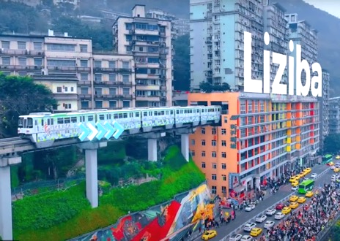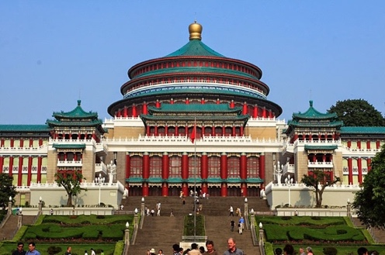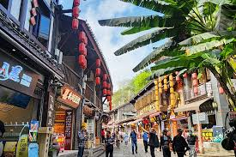

**D4: Lanzhou - Wuwei - Zhangye (B/L/D)**

- Transfer to Wuwei by Bus

- Kumarajiva Stupa

- Zhangye Desert Park

- Overnight at Zhangye

*Hotel : Xinshengyue International Hotel or similar 4\**

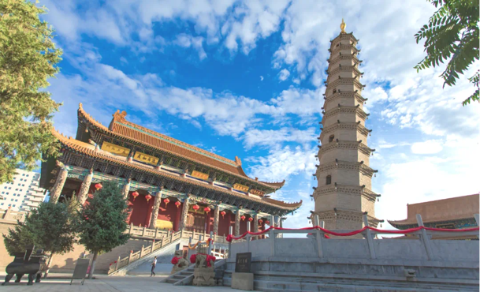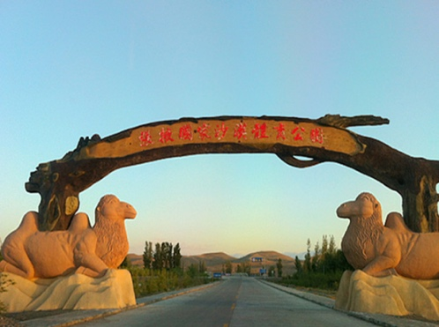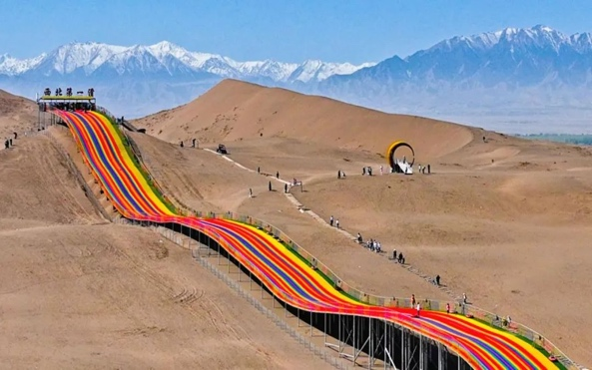

**09 Hari CHINA**

**ZHANGJIAJIE - CHONGQING - LANZHOU - ZHANGYE (MOSLEM TOUR)**

**D5: Zhangye - Lanzhou (B/L/D)**

- Zhangye Qicai Danxia Scenic Spot (included battery car)

- Visit Zhangye Mosque

*Hotel : Holiday Inn Express Hotel or similar 4\**

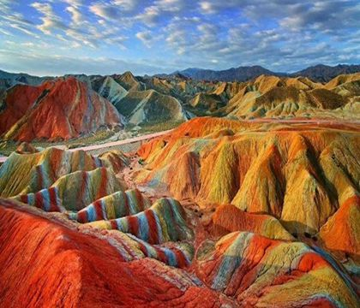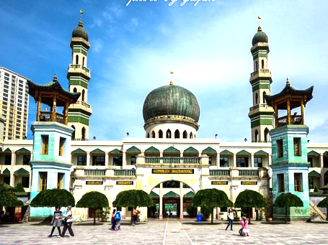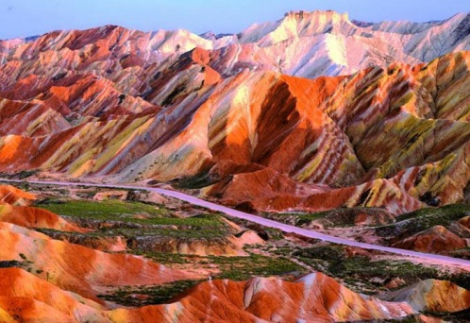

**D6: Lanzhou - Chongqing (B/-/D)**

- Transfer to Chongqing by Bullet Train

- ***Lunch on Train by own arrangement***

- Arrived Chongqing, Visit Hongya Cave

*Hotel : Shengming International Hotel or similar 4\**

**D7: Chongqing - Zhangjiajie (B/L/D)**

- Transfer to Zhangjiajie by Bullet Train

- ***Lunch on Train by own arrangement***

- Junsheng Sand Painting Gallery

*-* ***Optional: Tianmen Fox Lady Show +400 RMB/Pax***

*Hotel: Yunxi Meijing Hotel or similar 4\**

**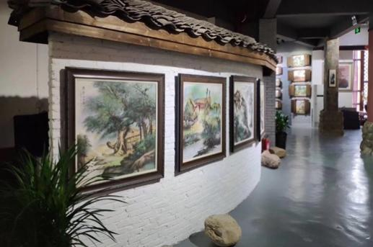****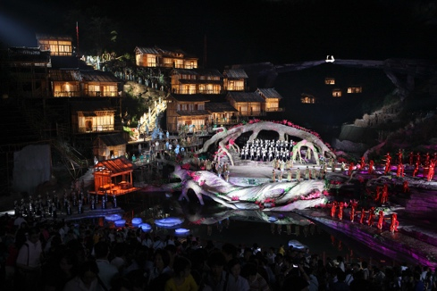**

**D8: Zhangjiajie - Airport out - Jakarta (B/L/D)**

*-* ***Optional: Tianmen Mountain (incl cable car), Glass Plank, Tianmen Cave (incl escalator) : +500RMB/Pax***

- ***Optional: 72 odd Buildings +200RMB/Pax***

- Transfer out to Airport, ETD 0330, end of service, ETA 0840 (tiba Jakarta Senin Pagi)

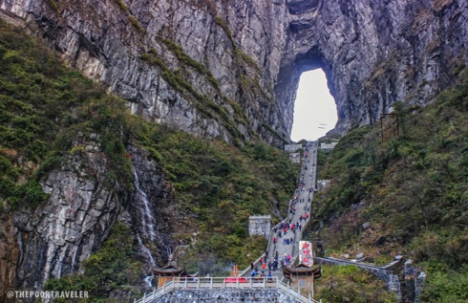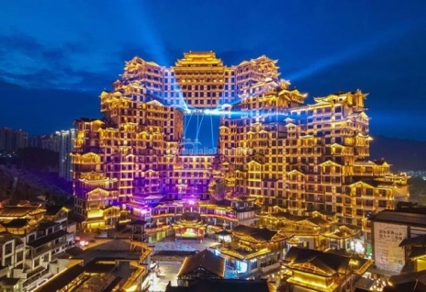

**\*\*\*END OF PROGRAM\*\*\***

**\*\*Jadwal perjalanan dan penerbangan dapat berubah sewaktu-waktu tanpa pemberitahuan terlebih dahulu\*\***

|  |  |  |  |  |  |  |  |
| --- | --- | --- | --- | --- | --- | --- | --- |
| **Departure Date**  **(2025)** | **Airlines** | **Adult**  **(Twin /Triple)** | **Adult (Single)** | **Child**  **(Twin/X-Bed)** | **Child**  **(No Bed)** | **Visa Group** | **Tipping**  **(D, LG, TL)** |
| **MEI : 04, 11, 18, 25** | **Citilink** | **18,900** | **21,400** | **18,900** | **18,400** | **900** | **775** |

**Catatan :**

**\*Masuk toko wajib : Chinese Medicine (1 shop)**

**\*Harga dalam ribu RUPIAH (IDR .000)**

**Biaya Tour Telah Termasuk:**

* Tiket pesawat internasional kelas ekonomi (non-refundable, non-endorsable, non-reroutable).
* Airport Tax International (Subject to Change)
* Makan sesuai acara (MP = Makan Pagi, MS = Makan Siang, MM = Makan Malam)
* Akomodasi, menginap di Hotel 4* dengan kondisi 1 kamar diisi oleh 2 orang dewasa (twin share).
* Bagasi gratis 1 pc dengan berat maksimum **15** kg dan hand carry gratis 1 pc dengan berat maksimum 7 kg.
* Tour Leader yang berpengalaman
* Bus

## Biaya Tour Tidak / Belum Termasuk :

* Group Visa to China @ **IDR 900,000**
* Pengeluaran pribadi seperti: mini bar, room service, telepon, laundry,dll.
* Tour atau show tambahan (optional) yang diadakan selama perjalanan @ RMB 300 s.d. RMB 500 per show
* Biaya kelebihan berat bagasi (excess / extra baggage)
* Tipping (untuk Guide dan Driver serta Tour Leader) sebesar Rp. 775.000,- dibayar pada saat pelunasan tour
* Biaya Single Supplement bagi Peserta yang menempati 1 kamar sendiri.
* TIKET TIDAK BISA EXTEND
* Karantina di China (hanya jika diperlukan)
* Asuransi Perjalanan

# Syarat pembuatan Group Visa to China (ZHANGJIAJIE):

*Scan pssport halaman 2 dan 3 (yang ada foto dan biodata), tegak lurus dan satu layar penuh.

*Masa berlaku passport minimal 6 bulan sebelum tanggal keberangkatan.

*Scan semua cap imigrasi pada lembar passport di negara yang dikunjungi dalam 3 tahun terakhir.

*Pas Foto terbaru (3 bulan terakhir), **ukuran 43 mm (lebar) x 62 mm (tinggi)**, latar belakang putih, tanpa bingkai.

**Penting**: hasil scan passport dan file pas foto harus dalam **format JPG atau JPEG**, **bukan PDF** atau yang lain.