**09 Hari CHINA**

**ZHANGJIAJIE - FENGHUANG - CHONGQING**

**Flight details:**

**From Jakarta direct to Zhangjiajie (setiap Kamis)**

**QG8840 1940-0225+1 (Jakarta - Zhangjiajie)**

**QG8841 0325-0825 (Zhangjiajie - Jakarta)**

**Itinerary:**

**D1: Jakarta - Zhangjaijie (-)**

- Berangkat menuju Zhangjiajie (Citilink Direct Flight) ETD 1940, Arrived Zhangjiajie ETA 0225+1 (tiba Jumat dini hari)

- Check in Hotel

*Hotel : Vienna Hotel or similar 4\**

**D2: Zhangjiajie - Fenghuang - Youyang (B/L/D)**

- Transfer to Fenghuang Phoenix Ancient Town by Bus (+/- 3 hours)

- Tuojiang Scenery, Hongqiao Art Building, Wanming Tower, Shawan Scenic Spot, Shiban Old Street

- Transfer to Youyang by Bus (+/- 2.5 hours)

- Check in Hotel

*Hotel : Taohuayuan Forest Hotel or similar 4\**

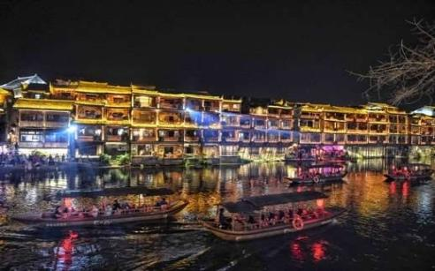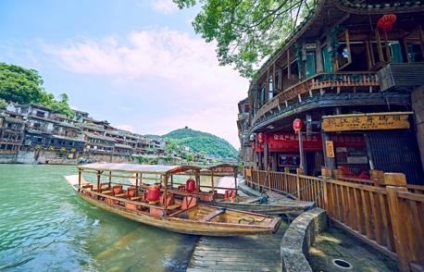

**D3: Youyang - Chongqing (B/L/D)**

- Transfer to Chongqing by Bus (+/- 5 hours)

- Arrived Chongqing, Visit Kuixinglou (22nd floor), Jiefangbei Street, Hongya Cave

- Special Hotpot Dinner at Pipayuan

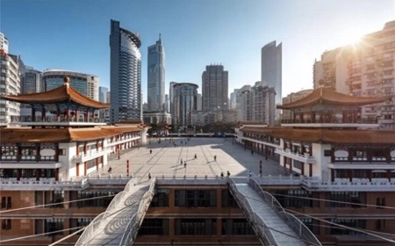 *Hotel : Days Inn or similar 4\**

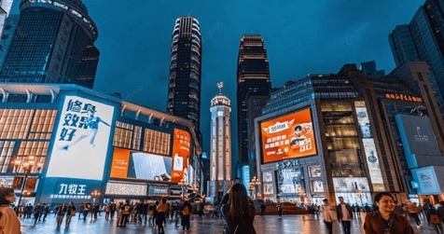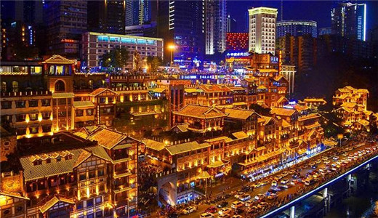

**D4: Chongqing - Qianjiang (B/L/D)**

- Ciqikou Ancient Town

- Liziba Light Railway (photo stop)

- Transfer to Qianjiang by Bus (+/- 4.5 hours)

- Visit Zhuoshui Ancient Town at night, enjoy the Largest Rainbow Bridge in Asia

*Hotel : Pokhara Hotel or similar 4\**

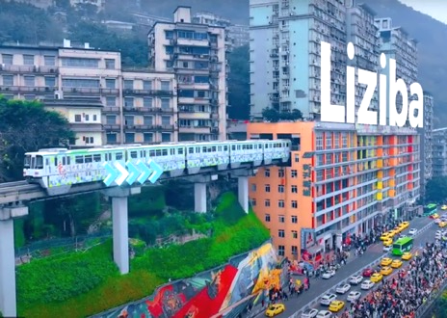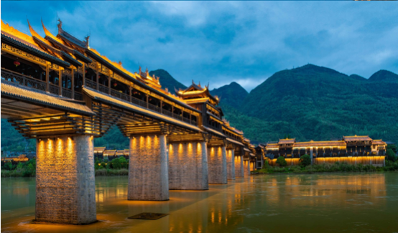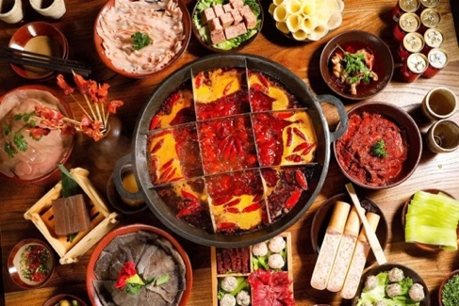

**09 Hari CHINA**

**ZHANGJIAJIE - FENGHUANG - CHONGQING**

**D5: Qianjiang - Zhangjiajie (B/L/D)**

- Transfer to Zhangjiajie by Bus (+/- 4.5 hours)

*-* ***Optional: Tianmen Mountain (incl cable car), Glass Plank, Tianmen Cave (incl escalator) : +500RMB/Pax***

*-* ***Optional: Tianmen Fox Lady Show +400RMB/Pax***

*Hotel: Xintiandi Huatian Hotel or similar 5* local*

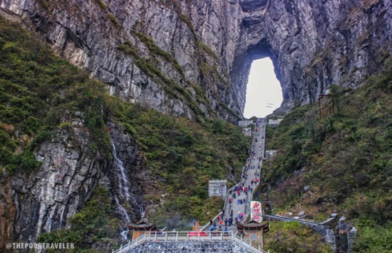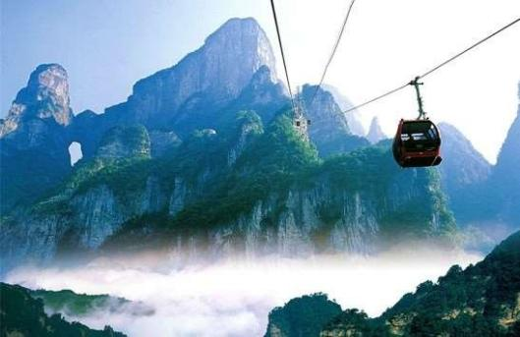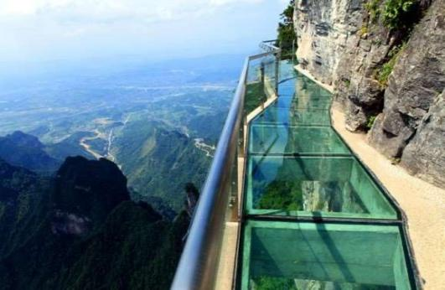

**D6: Zhangjiajie (B/L/D)**

**-** Visit Zhangjiajie National Forest Park

- Yuanjiajie, Bailong Lift (up and down)

- Avatar Mountain

*Hotel: Xintiandi Huatian Hotel or similar 5* local*

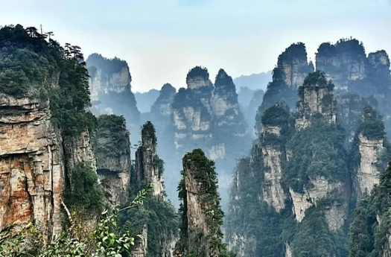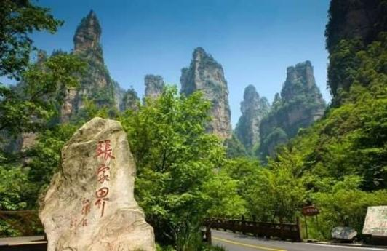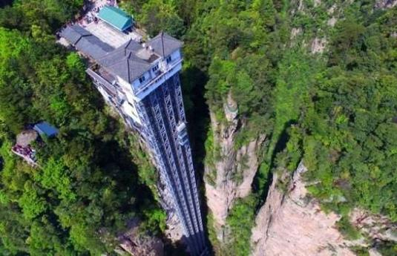

**D7: Zhangjiajie (B/L/D)**

- Golden Whip Stream

- Shui Rao Si Men

*****Hotel: Xintiandi Huatian Hotel or similar 5* local*

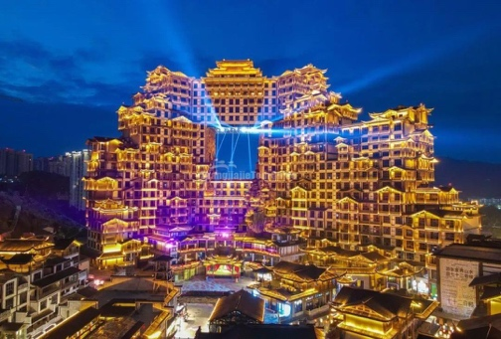**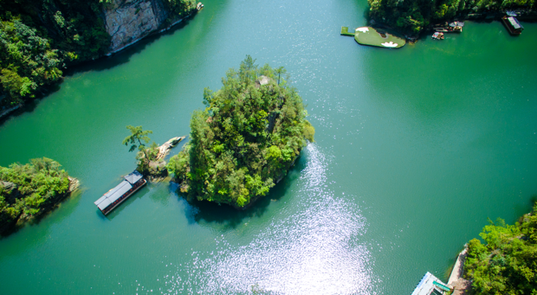***\**

**D8: Zhangjiajie - Airport out - Jakarta (B/L/D)**

*-* ***Optional: Baofeng Lake (incl cruise+battery car) +350RMB/Pax***

- Dayong Ancient Town

- 72 odd Buildings

- Transfer out to Airport, ETD 0335, end of service, ETA 0825

**\*\*\*END OF PROGRAM\*\*\***

**\*\*Jadwal perjalanan dan penerbangan dapat berubah sewaktu-waktu tanpa pemberitahuan terlebih dahulu\*\***

|  |  |  |  |  |  |  |  |
| --- | --- | --- | --- | --- | --- | --- | --- |
| **Departure Date**  **(2024)** | **Airlines** | **Adult**  **(Twin /Triple)** | **Adult (Single)** | **Child**  **(Twin/X-Bed)** | **Child**  **(No Bed)** | **Visa** | **Tipping**  **(D, LG, TL)** |
| **OKT : 24, 31** | **Citilink** | **12,900** | **15,400** | **12,900** | **12,400** | **900** | **775** |
| **NOV : 07, 14, 21, 28** | **Citilink** | **12,900** | **15,400** | **12,900** | **12,400** | **900** | **775** |
| **DES : 05, 12** | **Citilink** | **12,900** | **15,400** | **12,900** | **12,400** | **900** | **775** |
| **DES 19** | **Citilink** | **15,400** | **17,900** | **15,400** | **14,900** | **900** | **775** |

**Catatan :**

**\*Masuk toko wajib : Chinese Medicine, Jade, Latex, Silk, Tea**

**\*Harga dalam ribu RUPIAH (IDR .000)**

**\*High Season (19 DES) + 2.500.000**

**Biaya Tour Telah Termasuk:**

* Tiket pesawat internasional kelas ekonomi (non-refundable, non-endorsable, non-reroutable).
* Airport Tax International (Subject to Change)
* Makan sesuai acara (MP = Makan Pagi, MS = Makan Siang, MM = Makan Malam)
* Akomodasi, menginap di Hotel 4* dengan kondisi 1 kamar diisi oleh 2 orang dewasa (twin share).
* Bagasi gratis 1 pc dengan berat maksimum 15kg dan hand carry gratis 1 pc dengan berat maksimum 7 kg.
* Tour Leader yang berpengalaman
* Bus

## Biaya Tour Tidak / Belum Termasuk :

* Visa China (Guilin) @ **IDR 900,000**
* Pengeluaran pribadi seperti: mini bar, room service, telepon, laundry,dll.
* Tour atau show tambahan (optional) yang diadakan selama perjalanan @ RMB 300 s.d. RMB 500 per show
* Biaya kelebihan berat bagasi (excess / extra baggage)
* Tipping (untuk Guide dan Driver serta Tour Leader) sebesar Rp. 775.000,- dibayar pada saat pelunasan tour
* Biaya Single Supplement bagi Peserta yang menempati 1 kamar sendiri.
* TIKET TIDAK BISA EXTEND
* Karantina di China (hanya jika diperlukan)
* Asuransi Perjalanan

# Syarat pembuatan Group Visa to China (ZHANGJIAJIE):

*Scan pssport halaman 2 dan 3 (yang ada foto dan biodata), tegak lurus dan satu layar penuh.

*Masa berlaku passport minimal 6 bulan sebelum tanggal keberangkatan.

*Scan semua cap imigrasi pada lembar passport di negara yang dikunjungi dalam 3 tahun terakhir.

*Pas Foto terbaru (3 bulan terakhir), **ukuran 43 mm (lebar) x 62 mm (tinggi)**, latar belakang putih, tanpa bingkai.

**Penting**: hasil scan passport dan file pas foto harus dalam **format JPG atau JPEG**, **bukan PDF** atau yang lain.